**JE DECOUVRE LA BIBLE**

**Manuel de l’élève**

[**https://cloud.eud.adventist.org/index.php/s/WG9PAEX2F6ckEBe**](https://cloud.eud.adventist.org/index.php/s/WG9PAEX2F6ckEBe)

**Manuel de l’animateur**

[**https://cloud.eud.adventist.org/index.php/s/CaPXobQptWTMmH9**](https://cloud.eud.adventist.org/index.php/s/CaPXobQptWTMmH9)

**Bricolage et application de la semaine**

**BRICOLAGE**

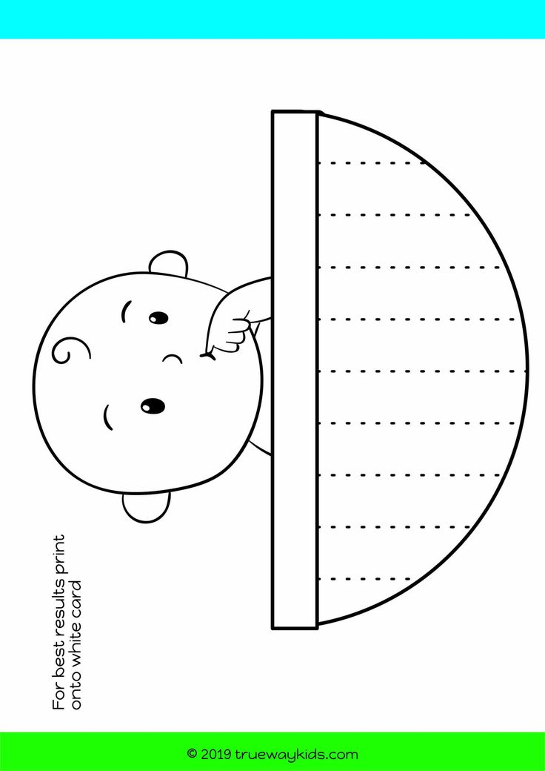

**APPLICATION DE LA SEMAINE**

