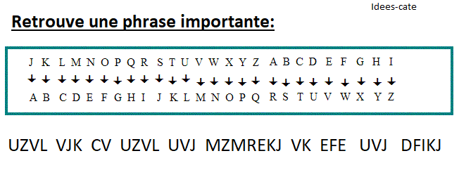page1image3485500064page1image3484819552page1image3484821184page1image3484821472